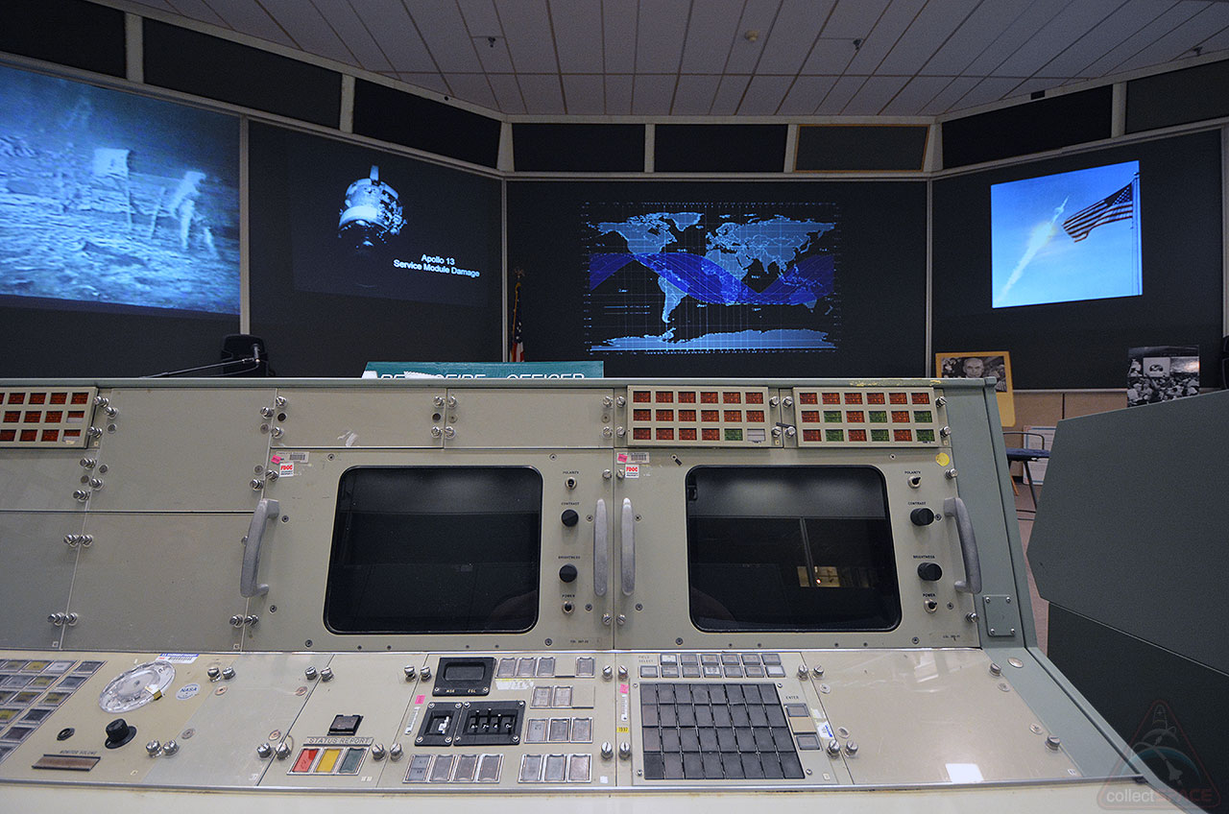

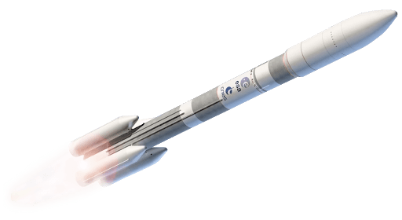

***Waiting for input…***

**The value of g at the surface of the earth is 9.78 N/kg, and on the surface of Venus the magnitude of g is 8.6 N/kg. A cosmonaut has a mass of 60 kg on the surface of the earth. What will her weight be on the surface of Venus?**

**Second Problem**

Problem 1:

Two identical cars collide head on. Each car is traveling at 100 km/h100 km/h. The impact force on each car is the same as hitting a solid wall at:

(a) 100 km/h

(b) 200 km/h

(c) 150 km/h

(d) 50 km/h​

Answer:

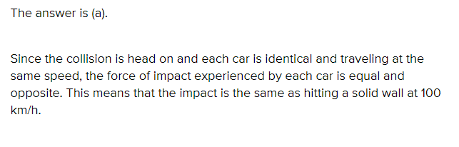

Problem 2:

The value of g at the surface of the earth is 9.78 N/kg, and on the surface of Venus the magnitude of g is 8.6 N/kg. A cosmonaut has a mass of 60 kg on the surface of the earth. What will her weight be on the surface of Venus?

Answer:

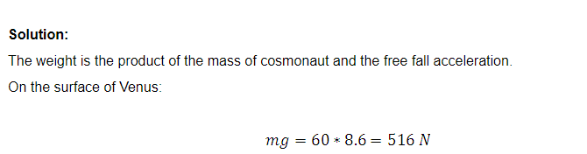

Problem 3:

The space shuttle is orbiting the Earth at a distance of about 300 km from its surface. At that distance, the gravitational acceleration is almost the same as that on the surface. How long does it take for the shuttle to complete one orbit around the Earth? Assume that the orbit is circular.

Disregard air resistance.

Answer:

